**Chapter 5**

**Multiple Integration**

**5.4 Triple Integrals**

**Section Exercises**

**In the following exercises, evaluate the triple integrals over the rectangular solid box **

181.  where 

Answer: 

182.  where 

Answer: 

183.  where 

Answer: 

184.  where 

Answer: 

**In the following exercises, change the order of integration by integrating first with respect to  then  then **

185. 

Answer: 

186. 

Answer: 

187. 

Answer: 

188. 

Answer: 

189. Let  be continuous functions on  and  respectively, where  are real numbers such that  Show that

Answer: This is a proof; therefore, no answer is provided.

190. Let  be differential functions on  and  respectively, where  are real numbers such that  Show that In the following exercises, evaluate the triple integrals over the bounded region 

Answer: This is a proof; therefore, no answer is provided.

191.  where 

Answer: 

192.  where 

Answer: 

193. , where 

Answer: 

194. , where 

Answer: 

**In the following exercises, evaluate the triple integrals over the indicated bounded region **

195.  where 

Answer: 

196.  where 

Answer: 

197.  where 

Answer: 

198.  where 

Answer: 

**In the following exercises, evaluate the triple integrals over the bounded region  of the form **

199.  where 

Answer: 

200.  where 

Answer: 

201.  where 

Answer: 

202.  where 

Answer: 

**In the following exercises, evaluate the triple integrals over the bounded region**



203.  where 

Answer: 

204.  where 

Answer: 

205.  where 

Answer: 

206.  where 

Answer: 

**In the following exercises, evaluate the triple integrals over the bounded region**

** where  is the projection of onto the -plane.**

207.  where 

Answer: 

208.  where 

Answer: 

209.  where 

Answer: 

210.  where 

Answer: 

211. The solid  bounded by  , and  is shown in the following figure. Evaluate the integral  by integrating first with respect to then 

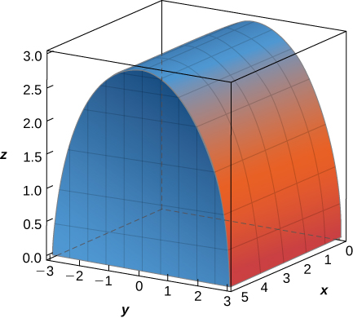

Answer: 

212. The solid bounded by    and  is given in the following figure. Evaluate the integral  by integrating first with respect to  then  and then 

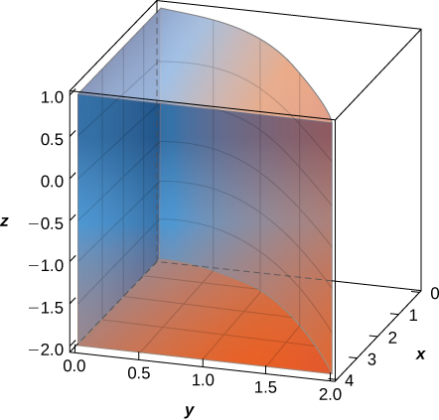

Answer: 

213. **[T]** The volume of a solid  is given by the integral  Use a computer algebra system (CAS) to graph  and find its volume. Round your answer to two decimal places.

Answer: 

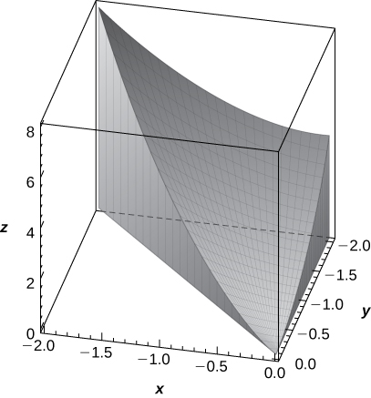

214. **[T]** The volume of a solid  is given by the integral  Use a CAS to graph  and find its volume  Round your answer to two decimal places.

Answer: 

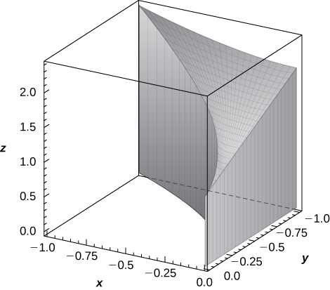

**In the following exercises, use two circular permutations of the variables  to write new integrals whose values equal the value of the original integral. A circular permutation of**  **is the arrangement of the numbers in one of the following orders:]**

215. 

Answer:  

216. 

Answer:  

217. 

Answer:  

218. 

Answer:  

219. Set up the integral that gives the volume of the solid  bounded by  and  where 

Answer: 

220. Set up the integral that gives the volume of the solid  bounded by  and  where 

Answer: 

221. Find the average value of the function over the parallelepiped determined by  and 

Answer: 

222. Find the average value of the function over the solid situated in the first octant.

Answer: 

223. Find the volume of the solid  that lies under the plane  and whose projection onto the  is bounded by  and 

Answer: 

224. Find the volume of the solid *E* that lies under the plane  and whose projection onto the  is bounded by  and 

Answer: 

225. Consider the pyramid with the base in the  of  and the vertex at the point 

1. Show that the equations of the planes of the lateral faces of the pyramid are    and 
2. Find the volume of the pyramid.

Answer: a. Answers may vary; b. 

226. Consider the pyramid with the base in the  of  and the vertex at the point 

1. Show that the equations of the planes of the side faces of the pyramid are    and 
2. Find the volume of the pyramid.

Answer: a. Answers may vary; b. 

227. The solid  bounded by the sphere of equation  with  and located in the first octant is represented in the following figure.

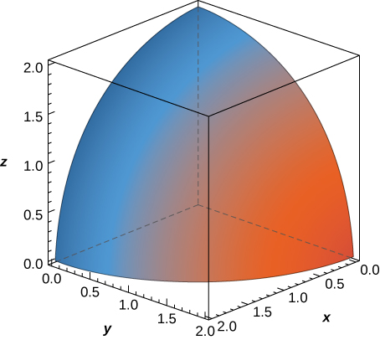

1. Write the triple integral that gives the volume of  by integrating first with respect to then with  and then with 
2. Rewrite the integral in part a. as an equivalent integral in five other orders.

Answer: a.  b.     

228. The solid  bounded by the equation  and located in the first octant is represented in the following figure.

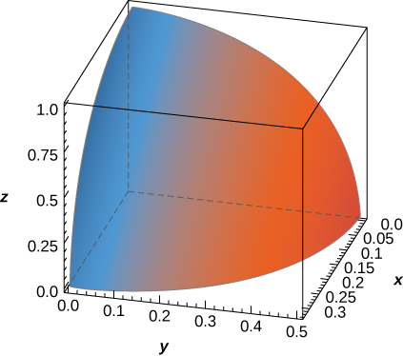

1. Write the triple integral that gives the volume of  by integrating first with respect to then with  and then with 
2. Rewrite the integral in part a. as an equivalent integral in five other orders.

Answer: a.  b.     

229. Find the volume of the prism with vertices  

Answer: 

230. Find the volume of the prism with vertices 

Answer: 

231. The solid  bounded by  and situated in the first octant is given in the following figure. Find the volume of the solid.

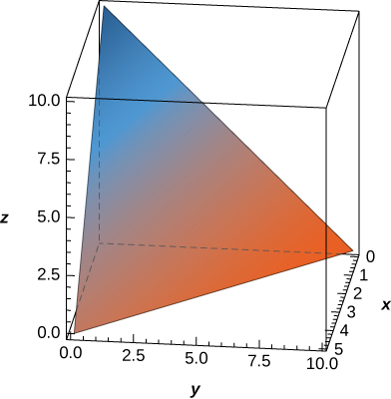

Answer: 

232. The solid  bounded by  and situated in the first octant is given in the following figure. Find the volume of the solid.

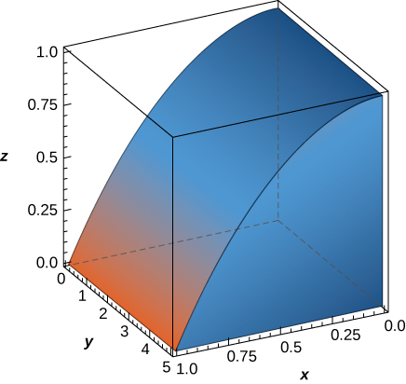

Answer: 

233. The midpoint rule for the triple integral  over the rectangular solid box  is a generalization of the midpoint rule for double integrals. The region  is divided into subboxes of equal sizes and the integral is approximated by the triple Riemann sum  where  is the center of the box  and  is the volume of each subbox. Apply the midpoint rule to approximate  over the solid  by using a partition of eight cubes of equal size. Round your answer to three decimal places.

Answer: 

234. **[T]**

1. Apply the midpoint rule to approximate  over the solid  by using a partition of eight cubes of equal size. Round your answer to three decimal places.
2. Use a CAS to improve the above integral approximation in the case of a partition of  cubes of equal size, where 

Answer: a.  b. Answers will vary

235. Suppose that the temperature in degrees Celsius at a point  of a solid  bounded by the coordinate planes and  is  Find the average temperature over the solid.

Answer: 

236. Suppose that the temperature in degrees Fahrenheit at a point  of a solid  bounded by the coordinate planes and  is  Find the average temperature over the solid.

Answer: 

237. Show that the volume of a right square pyramid of height  and side length  is  by using triple integrals.

Answer: This is a proof; therefore, no answer is provided.

238. Show that the volume of a regular right hexagonal prism of edge length  is  by using triple integrals.

Answer: This is a proof; therefore, no answer is provided.

239. Show that the volume of a regular right hexagonal pyramid of edge length is  by using triple integrals.

Answer: This is a proof; therefore, no answer is provided.

240. If the charge density at an arbitrary point  of a solid  is given by the function  then the total charge inside the solid is defined as the triple integral  Assume that the charge density of the solid  enclosed by the paraboloids  and  is equal to the distance from an arbitrary point of  to the origin. Set up the integral that gives the total charge inside the solid 

Answer: 

This file is copyright 2016, Rice University. All Rights Reserved.